### 

### TITLE : ALTERNALTE EFFICIENT OXYGEN DELIVERY SYSTEM FOR PATIENTS

**DEPARTMENT OF ELECTRONICS & COMMUNICATION ENGINEERING**

**INNOVATE 2023**

**Date: 19-04-2023**

**A MINI PROJECT REPORT**

**PROJECT GUIDE:Ms. Murugeshwari Asst .prof**

***Submitted by***

|  |  |
| --- | --- |
| **VAISHALI.J** | **113320106048** |
| **SANGAVI.S** | **113320106035** |
| **MALAR VIZHI.S** | **113320106023** |

**Project Guide Signature**

**Abstract:**

* This project's goal is to track and supply the oxygen produced for patients who have been admitted to the intensive care unit by medical professionals, nurses, and patients' visitors. Effective and smooth condition monitoring is crucial for ICU patients since they need intensive care and constant observation.
* A doctor should report right away to the critical care unit whenever an emergency occurs, such as a rise in blood pressure, a heart attack, a stroke, etc. By gathering the medical information of every patient in the ICU, our project meets this demand. Doctors and nurses have access to this information at all times. So that medical professionals can immediately react to the patient, emergency circumstances might also be alerted.
* Attendees are unhappy and dejected because they are forbidden from seeing ICU patients. By displaying the patient's status and precise information in virtual mode, this doubt about the attendee's condition can be eliminated. Also, it lessens disturbances for ICU patients and lets the family know how the patient is doing.

**Introduction:**

* We decided to develop a new product of alternate efficient oxygen delivery system so we had to select a product that was more useful and in demand in the market so we came up with this idea .
* Doctors, nurses, and patients in the intensive care unit will benefit from the proposed idea.
* As we designed a convenience product so we decided to make our product available everywhere

**Need for the Project:**

* our plan focuses on producing oxygen without using any gas cylinders. As this product has evolved, new features have been added, like alerting the doctors and nurses when a patient is in an emergency, which lowers the patient mortality rate. When visitors to ICU patients aren't allowed to see these patients, they grow anxious and despondent. This confusion can be removed by showing the patient's state and relevant data in virtual mode. ICU patients are consequently less likely to be disturbed, and the family is more knowledgeable about the patient's condition.

**Proposed Work:**

**Working Solution for 1st part**

* A transmission cable connects each of the patient monitoring systems.
* The splitter is then attached to the transmitting cable.
* The nursing station displays the output from the splitter.
* Consequently, without having to enter the IC Unit, the nurse or doctor may see the patient's condition.
* Additionally, the transmitting cable is attached to the hospital's shared server, which records the patient's overall summary for future reference.
* The patient monitor is then linked to the module.
* The doctor who is treating the patient will receive a mobile phone alert in the event of any emergency circumstances.

**LCD KIT**:

* Liquid crystal display
* It show the blood oxygen level

**CONTROLLER BOARD:**

* In control board we are place liquid oxygen sensor
* Photo diode is placed in the control board
* We placed the finger light oxygen sensor it shows blood oxygen level in LCD.
* According to flow of blood

**RELAY BOARD:**

* Confere on
* Confere off
* Two type of speed (low and high)

**POWER SUPPLY KIT:**

* We have to convert Ac current into Dc current into Dc current
* To convert this we are using 12 volts adapter
* Ac supply voltage start to flow
* 5 volt Dc control operating voltage
* In this we are using fill wave rectifier because it will produce high efficiency
* Rectifies convert Ac to Dc
* To eliminate filler or noise we are using capacitor 1 MF.
* IC7805 Transistor are used
* After supply 5 volt it does not work so we give crystal oscillator which generator clock pulse 4 port.

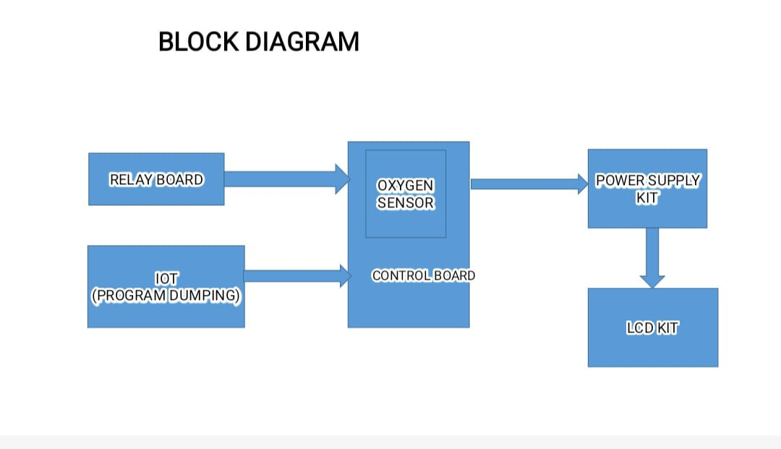

**Solution architecture for 2nd part**

**OXYGEN TUBE**: Nasal Cannula is a medical device to provide supplemental oxygen therapy to people who have lower oxygen levels. The device has two prongs and sits below the nose. The two prongs deliver oxygen directly into your nostrils.

**BUTTONS**: It has three button. High, medium, low. We can use buttons to calculate oxygen rate by automatically or manually.

**OXYGEN FLOW TO PATIENTS:** Nasal cannula Oxygen is generally delivered through tubing and a nasal cannula, sometimes called nasal prongs. The nasal cannula end of the tubing fits into your nose, and is the most common delivery accessory.

**OXYGEN REGULATED VALVE**: it reduces, controls, and measures the flow of oxygen to the patient to ensure a safe and effective working pressure. The regulator and flowmeter usually are coupled together into one mechanical fitting on the oxygen tank.

**DC MOTOR**: compressions of oxygen concentrators and ventilators.

**LCD DISPLAY AND LED INDICATOR**: it used to display patients heart beat level.

**ARDUINO** : Heart Beat And Body Temperature Monitoring using Arduino will detect the heart beat using the Pulse Sensor and body temperature using LM-35 sensor. Sensor and will show the readings in BPM (Beat Per Minute) on the LCD connected to it. The body Temperature will be displayed on serial monitor along with BPM readings.

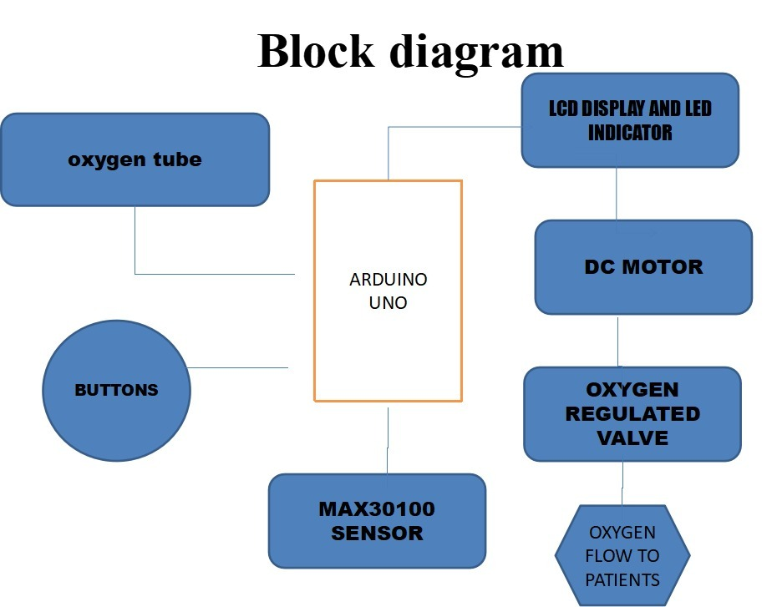

**Components Used:**

* IOT Board
* 2 Relay Card
* Control Board with oxygen sensor
* Power supply rate
* Oxygen Tube
* Buttons
* LCD display and LED indicator
* Arduino UNO
* MAX30100 sensor
* DC motor
* Oxygen regulated valve
* Oxygen flow to patients

**Result/Output:** 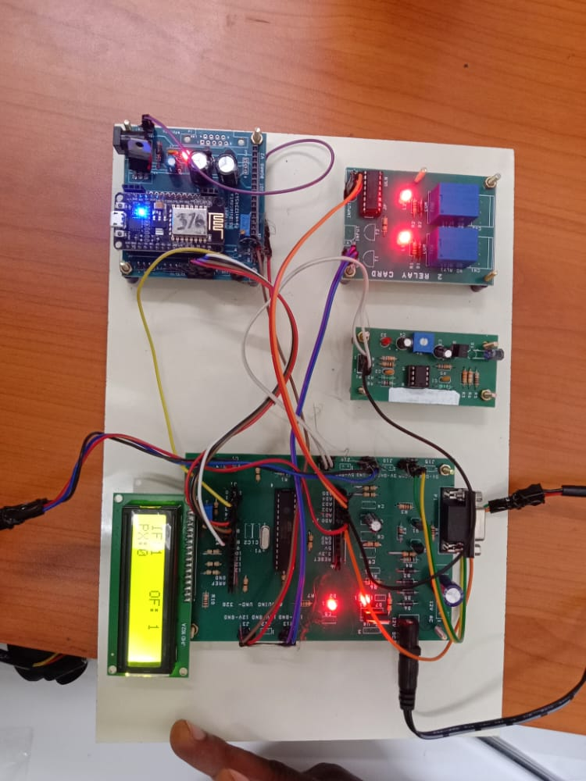

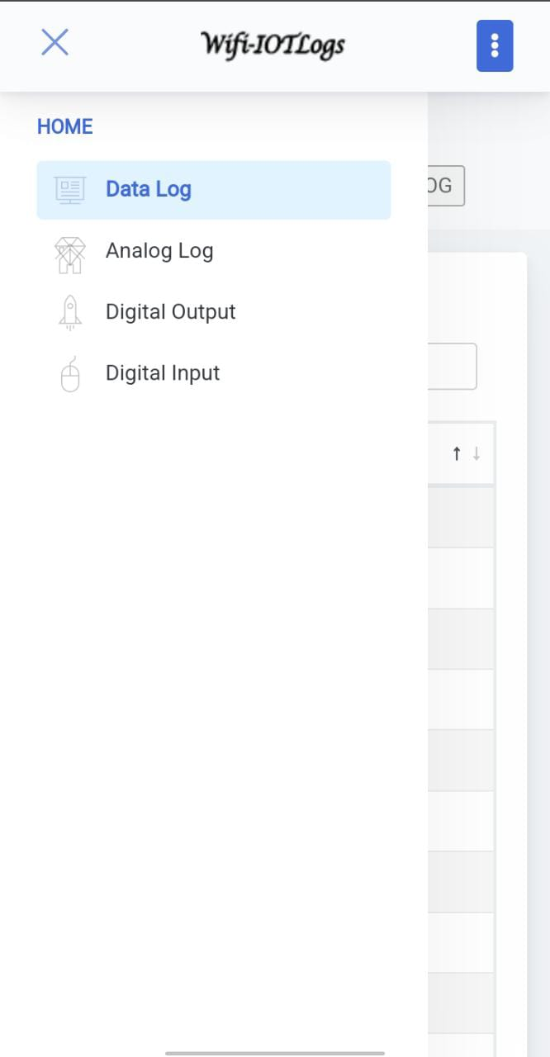

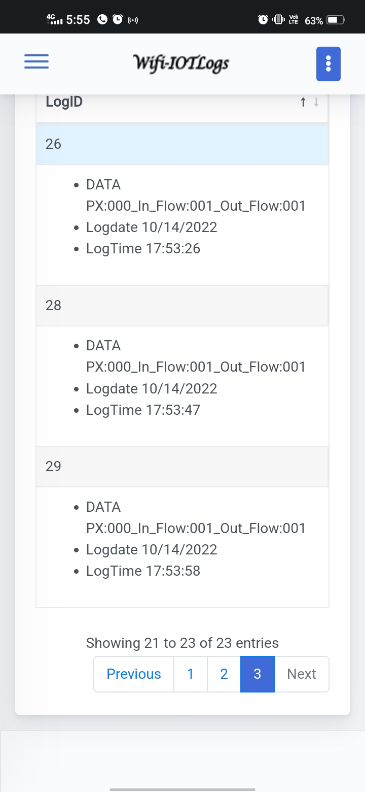



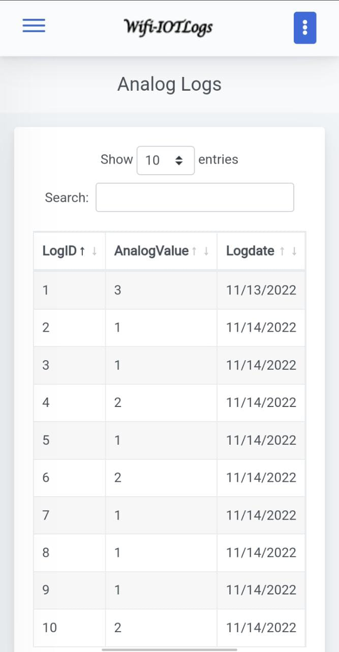

**Conclusion:**

* Through this project the infection rate of the patient will be reduced
* And the attendees will be able to see the patient virtually so they get some satisfaction
* And the oxygen delivery system will be effectively in use
* And it is also useful for the nurse who goes to each and every ICU ward and notes the readings of every patient
* Through this project the nurse can note the current status of the patient virtually in one place
* And with the help of the alert system the death rate can also be reduced

**Reference:**

1. B. W. Henderson and T. J. Dougherty, “How does photodynamic therapy work?,” *Photochem. Photobio.*, vol. 55, no. 1, pp. 147–157, Jan. 1992.
2. N. Bressler *et al.*, “Photodynamic therapy of subfoveal choroidal neovascularization in age-related macular degeneration with verteporfin. One-year results of 2 randomized clinical trials—TAP Report 1,” *Arch.*

*Ophthalmol.*, vol. 117, no. 2, pp. 1329–1348, Oct. 1999.

1. R. Bonnett, “Photosensitizers of the porphyrin and phtalocyanine series for photodynamic therapy,” *Chem. Soc. Rev.*, vol. 24, no. 1, pp. 19–33, Feb. 1995.
2. S. Wan, J. A. Parrish, R. R. Anderson, and M. Madden, “Transmittance of nonionizing radiation in human tissues,” *Photochem. Photobio.*, vol. 34, pp. 679–681, 1981.
3. W.-F. Cheong, S. A. Prahl, and A. J Welch, “A review of the optical properties of biological tissues,” *IEEE J. Quantum Electron.*, vol. 26, pp. 2166–2185, Dec. 1990.
4. S. Kershaw, “Two-photon absorption,” in *Characterization Techniques and Tabulations for Organic Nonlinear Optical Materials*, M. G. Kuzyk and C. W. Dirk, Eds. New York: Marcel Dekker, 1998.
5. W. G. Fisher, W. R. Partridge, Jr., C. Dees, and E. A. Wachter, “Simultaneous two-photon activation of type-I photodynamic therapy agents,” *Photochem. Photobio.*, vol. 66, no. 2, pp. 1415–155, Aug. 1997.
6. J. D. Bhawalkar, N. D. Kumar, C.-F. Zhao, and P. N. Prasad, “Twophoton photodynamic therapy,” *J. Clin. Lasers Med. Surg.*, vol. 15, no.

5, pp. 201–204, Sept.–Oct. 1997.

|  |
| --- |
| KAROTKI *et al.*: EFFICIENT SINGLET OXYGEN GENERATION UPON TWO-PHOTON EXCITATION |

1. P. K. Frederiksen and O. P. R. Jørgensen, “Two-photon photosensitized production of singlet oxygen,” *J. Amer. Chem. Soc.*, vol. 123, no. 6, pp. 1215–1221, Feb. 2001.
2. R. L. Goyan and D. T. Cramb, “Near-infrared two-photon excitation of protoporphyrin IX: Photodynamics and photoproduct generation,” *Photochem. Photobio.*, vol. 72, no. 6, pp. 821–827, Dec. 2000.
3. K. König, “Multiphoton microscopy in life sciences,” *J. Microsc.*, pt. 2, vol. 200, pp. 83–104, Nov. 2000.
4. M. Albota *et al.*, “Design of organic molecules with large two-photon absorption cross sections,” *Science*, vol. 281, no. 5383, pp. 1653–1656, Sept. 1998.

**Photos of Project:**

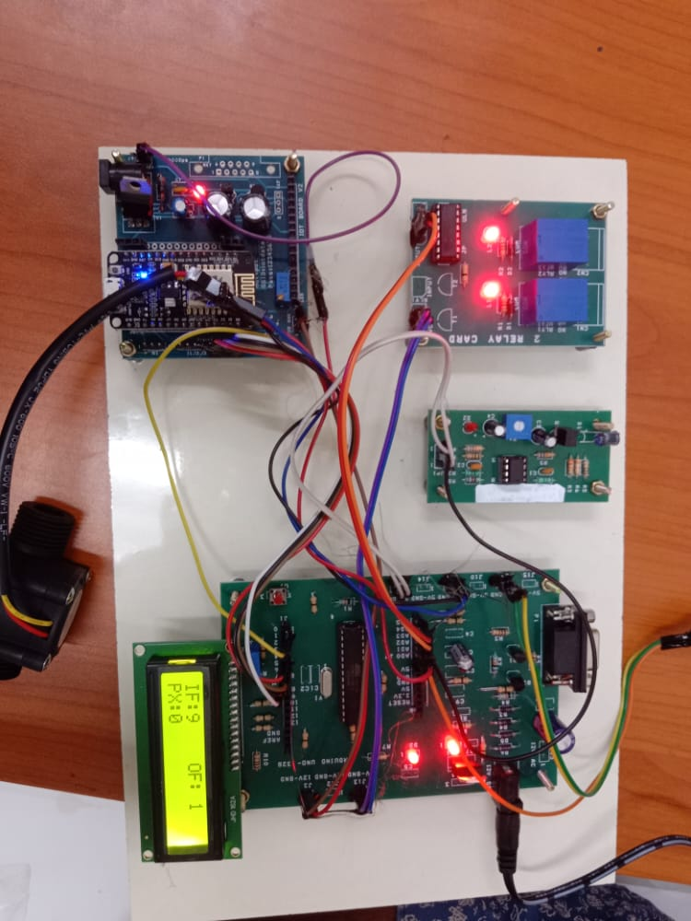

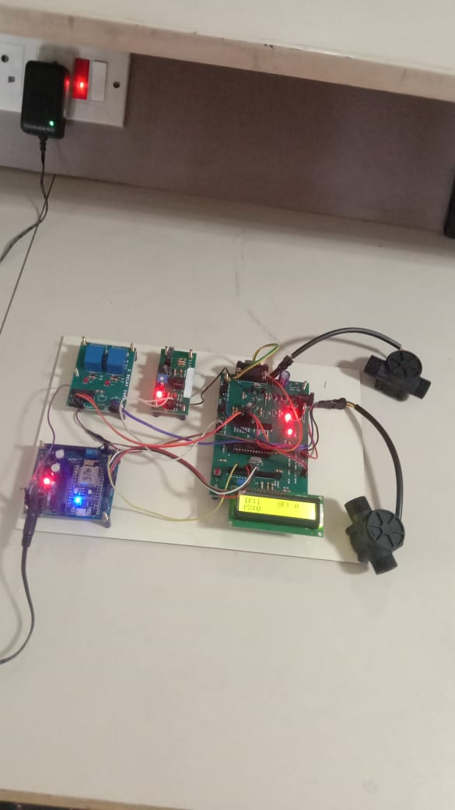

**Photo of Team members with Guide**

